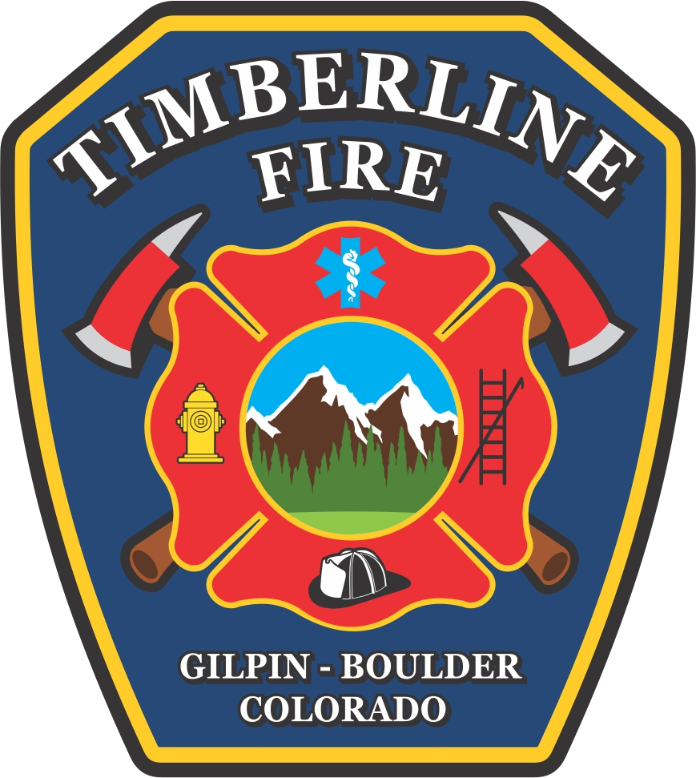

**MONTHLY FIRE CHIEFS REPORT**

**Regular Meeting: February 10, 2025**

**Operations:**

* We responded to 59 calls in January.
* Tender 54 is currently out of service for an exhaust manifold gasket replacement; hopefully be back in service by the end of the week.
* Engine 58 is out of service due to a leaking wheel seal. Hoping this will get repaired next week.
* We responded to a Fire on 1/20 that turned out to be a fully involved travel trailer. Everyone did a great job, and our automatic aid with Black Hawk Fire again worked seamlessly.
* We have responded to a handful of out-of-prescription pile burns.

**Wildland/Mitigation:**

* Mitigation work continues as the weather allows.
* Brush 52 left for the Palisade fire on 1/10 and returned on 1/25.
* Our second wildfire Movie was a huge success, and the next one is scheduled for March 15th.

**Administration:**

* 2025 Audit has been scheduled for June 16 and 17.
* Lots of time working on the RFP and construction coordination.
* Blood Drive at Station 5 is scheduled for June 7th. Please sign up!
* Chili Cookoff at Very Nice on March 9th, 2-5pm.

**R&R:**

* We have 7 new volunteers lined up for onboarding.
* We will be attending a recruitment event at Aims in March.